**The Diagnostics of the rotor misalignment of a permanent magnet motor**

**A A Afanasev1, V S Genin1, L N Vasileva1 and V G Grigorev2**

1Department of Automation and Management in Engineering Systems, Chuvash State University named after I.N. Ulyanov, 15, Moskovsky prospect, Cheboksary, Russia

2Department of Industrial Electronics, Chuvash State University named after I.N. Ulyanov, 15, Moskovsky prospect, Cheboksary, Russia

**Abstract.** A mathematical model of the magnetic field in the working gap of a brushless motor is considered in a case of rotor misalignment arising during manufacture, for example, due to defects in end shields, or in operation due to bearing wear. a gap in a uniform (circular ring). The stator gearing is taken into account on average using the Carter coefficient, the magnetic field in the inhomogeneous air gap, created by the rotor magnets and the stator winding current, is assumed to be plane-parallel, having a two-dimensional character. It was found that the rotor misalignment associated withthe rotational movement of the eccentricity causes nonsinusoidality of the idle EMF and pulsation of the electromagnetic moment with a frequency 3p times higher than the rotor speed. When the eccentricity is stationary, a variable EMF is induced along the rotor shaft, causing an alternating current in the circuit: shaft-bearings-bearing shields-stator housing. To clarify the nature of the defect in order to identify the actual misalignment of the rotor, it is recommended to control currents and voltages using specialized software and hardware complexes for spectrum analysis.

Electrical machines are widely used in various industries. They are the largest consumers, using up to 80% of all electricity generated in the country. In recent decades, thanks to the development of semiconductor power and microprocessor technology, permanent magnet motors have been successfully used. The main advantages of drives based on such electric motors:

• high short-term overload torque, reaching 10 times the nominal value;

• high energy indicators (, );

• significantly smaller weight and dimensions.

In particular, permanent magnet ac converter-fed motors are widely used in drives of automation and robotics systems, in vehicles.

Often, as a result of untimely identification of developing equipment defects, the likelihood of severe consequences in accidents increases, and the volume of repair work increases. In many industries, sudden engine failure can lead to irreparable consequences. In this regard, an important condition for the effective operation of electrical equipment is diagnostics through constant monitoring and assessment of the condition. This is especially true when using equipment that has reached its standard service life. Diagnostic monitoring of equipment also creates the prerequisites for the transition from a system of preventive maintenance to maintenance based on technical condition or maintenance, focused on reliability (RCM - Reliability Centered Maintenance), reducing operating costs.

The rotor misalignment of the brushless motor can occur during manufacture, for example, due to defects in end shields, or in operation due to bearing wear. In the first case, the section of the air gap with the minimum size (eccentricity) is stationary, associated with a specific place on the surface of the stator bore, in the second, it will rotate with the rotor. It should be noted that damage to bearing elements, along with turn-to-turn faults in the stator winding, is one of the most common types of damage.

In [1], using the conformal transformation of an uneven air gap in the plane  into a uniform (circular ring) in the plane  (Figure 1), the calculations of the magnetic field in the air gap of the engine were performed. When considering the phenomena in the engine caused by rotor misalignment, the following assumptions were made:

1) the magnetic permeabilities of the stator core and the rotor yoke are equal to infinity;

2) the gearing of the stator is taken into account on average using the Carter coefficient;

3) the magnetic field in the inhomogeneous air gap, created by the rotor magnets and the stator winding current, is plane-parallel, has a two-dimensional character.



Figure 1. Conformal transformation of an uneven air gap into a uniform one.

Conformal transformation is performed according to the formula [2]

 (1)

where ; – diametrical points of the inner circle;  - the radiuses of the inner and outer circumferences; it is an offset of the - centers of the circles.

The field in the annular region of the complex plane  is defined as the solution of the first boundary value problem with known scalar magnetic potentials  and , respectively, on the inner (unit radius) and outer (radius ) circles. Since the scalar magnetic potential under conformal transformations is an invariant quantity [3], the magnetic potential of the rotor magnets is represented by the expression

, (2)

where , – the coercive force of induction and height of magnets; – number of pairs of motor poles;  – the half of the angular distance between adjacent oppositely polarized magnets in radians.

The calculations were carried out in relation to the 6DVM300 A35 ac converter-fed motor (see Figure 2) [4], the serial production which was mastered by ChEAZ JSC (Cheboksary):  mm,  mm,  mm,  kA / m,  Nm.

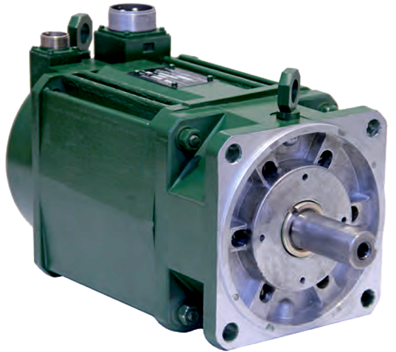

Figure 2. Ac converter-fed motor 6DVM300.

The dependence of the scalar potential on the inner boundary of the circular ring of the plane , the magnetic potential and radial induction inside the circular ring, etc. are obtained.

With the help of the conformal transformation (1), a connection is established between the magnetic inductions in the complex planes  and  [5]

. (3)

where

 (4)

The radial components of the magnetic inductions at the boundaries of the air gap, obtained according to (3) and (4), are shown in Figure 3. Due to the displacement of the inner circle in the direction of the radius with a zero angular coordinate (Figure 1), at values close to the maximum values are obtained induction maxima. Oscillations of induction on the graph are explained by the use of a limited number of terms of an infinite series.

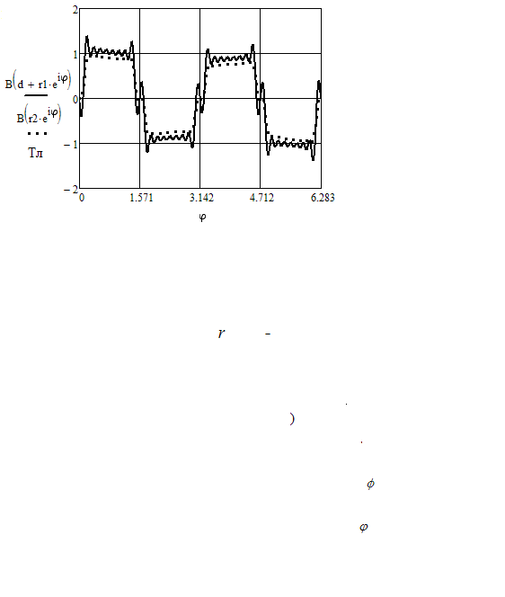

Figure 3. Values of magnetic inductions at the boundaries of the air gap in the plane.

Then, the amplitude values  of the inductances of mutual inductance of the rotor magnets with the phase A of the stator winding are determined, taking into account that the minimum air gap rotates with the rotor

, (5)

with which you can find the flux linkage  and the idle EMF  of this phase

, (6)

, (7)

where – the electric angular is frequency of the considered four-pole motor.

Figure 4 shows the idle EMF caused by the rotor magnets, calculated according to (9), (10) for a 6DVM300 A35 ac converter-fed motor.

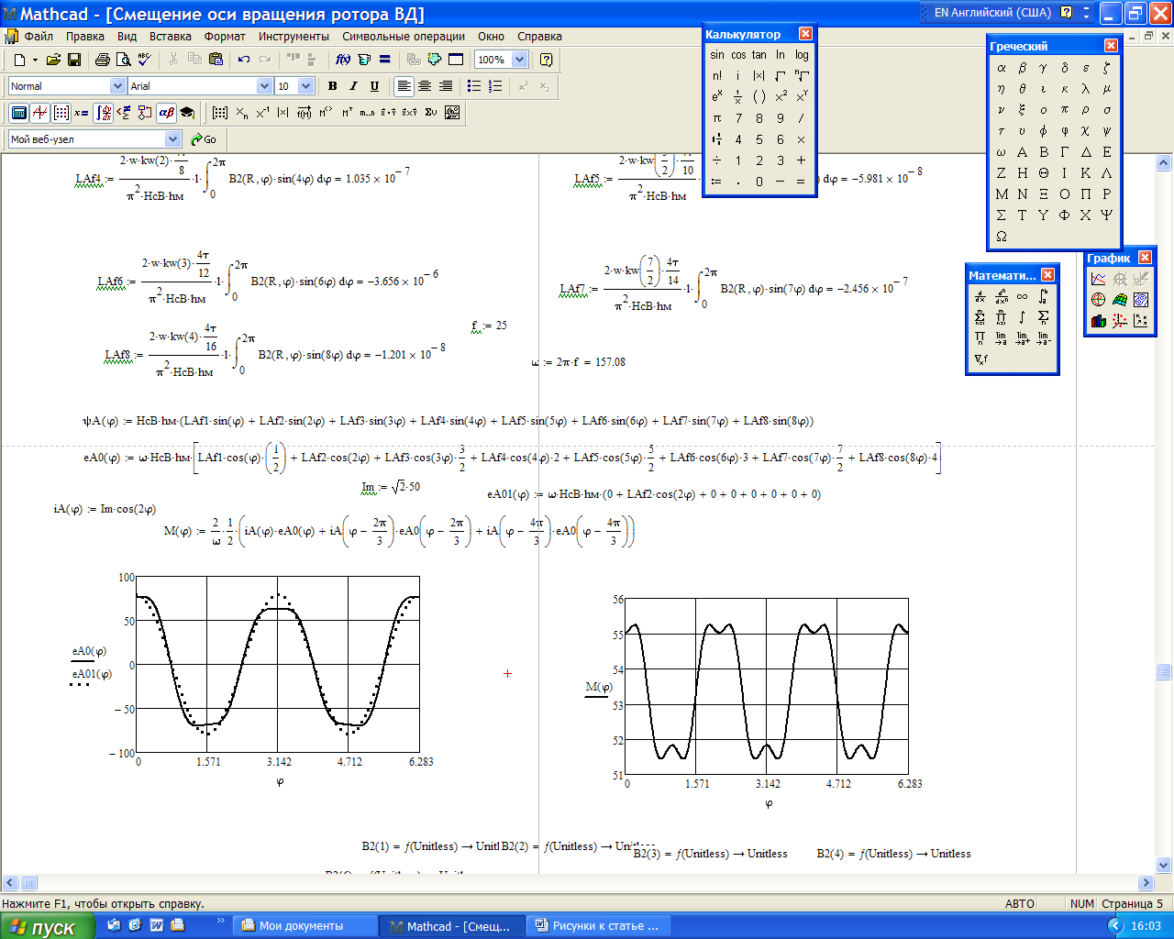

Figure 4. No-load EMF of phase A (resulting and fundamental harmonic ) due to the rotor magnets.

We suppose that a permanent magnet motor has almost sinusoidal current and voltage in the stator winding, the phase angles of which can be linked by hardware and software to the angular position of the rotor.

The electromagnetic torque of the motor is determined using equality (7) and assuming that the phase currents are in antiphase with the no-load EMF

, (11)

where .

The graphic of the change in the electromagnetic moment, built according to (11), is shown in Figure 5. We see that with a rotor misalignment, for example, 1 mm, an alternating component of the electromagnetic moment appeared, which has a frequency six times higher than the frequency of the stator current, and the ripple depth of which at rated current is 7.1% of rated torque.

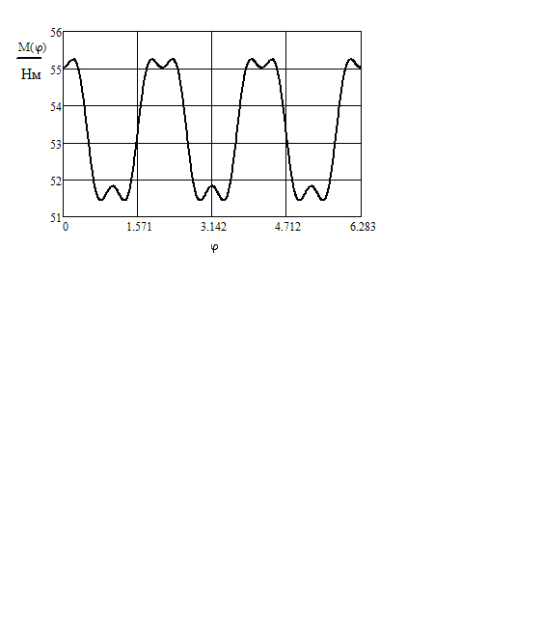

Figure 5. Electromagnetic moment at rated stator current as a function of the angular position of the rotor.

If the eccentricity of the rotor is stationary relative to the stator surface, the symmetric magnetic field in the circular ring of the plane will rotate, and the function, connecting the values and  of induction in planes and, remains stationary. As a result, the magnetic field in the poles (magnets) and the rotor yoke will begin to pulsate, and the total alternating magnetic flux, closed around the rotor shaft, will be nonzero. In this case, as is known [6], an EMF is induced along the shaft and an alternating current flows, closing through the bearings, end shields and the stator housing. As a result, bearing heating may occur, accompanied by electrochemical erosion.

From the foregoing it follows that the excess of the permissible values of the rotor misalignment of the brushless motor can be detected by monitoring the voltage at the motor terminals, the consumed current and the temperature. However, the asymmetry and non-sinusoidality of phase currents and voltages, accompanied by an increase in temperature, can be caused by other reasons, for example, turn-to-turn faults in the stator windings, magnetic asymmetry of the rotor caused by inhomogeneous magnetization of magnets, and other reasons.

Thus, monitoring of temperature, currents and voltages may indicate a malfunction. To clarify the nature of the defect, it is possible to recommend vibrodiagnostics of the state of the engine elements [7], which, however, is a rather expensive and time-consuming measure. Recently, methods for diagnosing electrical machines have been developed based on the spectral analysis of the current signal [8-10]. The use of specialized software and hardware complexes [11] makes it possible to determine the state of various engine elements with a high degree of reliability.

**Conclusions**

1. Misalignment of the rotor of a brushless motor can occur during manufacture, for example, due to defects in end shields, or in an operation due to wear of bearings, which happens very often.

2. The misalignment of the rotor, associated with the rotational movement of the eccentricity, causes nonsinusoidality of the idle EMF and pulsation of the electromagnetic moment with a frequency of 3*p* times the rotor speed. When the eccentricity is stationary, a variable EMF is induced along the rotor shaft, causing an alternating current in the circuit: shaft-bearings-bearing shields-stator housing.

3. To clarify the nature of the defect in order to identify the actual misalignment of the rotor, it is possible to recommend monitoring currents and voltages using specialized software and hardware complexes for spectrum analysis.

**References**

1. Afanasev A A 2020 *Mathematical Modeling of Electromechanical Systems (*Cheboksary: Chuvash State Univesity) p 274
2. Koppenfels V and Shtalman F 1963 *Practice of Conformal Mappings* (Moscow: Izd-vo inostrannoi literatury) p 407
3. Polyanin A.D. 2001 *A Handbook of Linear Equations in Mathematical Physics* (Moscow: Fizmatlit) p 576
4. *Rules for the Citing of Sources* Available from: https://www.cheaz.ru/assets/images/production/10-ensber/1-electrodvig/2-6-dvm/6dvm.pdf
5. Ivanov-Smolenskii A V and Abramkin Yu V 1985 *Application of Conformal Transformation in Electrical Machine Calculations for Electrical Machines. Analytical Methods* (Moscow: Tipografiya MEI) p 85
6. Alekseeva M M 1967 *Machine Generators of Increased Frequency* (L.: Energiya) p 344
7. *Condition Monitoring and Diagnostics of Machines. Vibration Monitoring of the State of Machines Part 9. Methods for Diagnosing Electric Motors* (ISO/DIS 13373-9, YuT)
8. Thomson W T and Rankin D 1987 *Case Histories of Rotor Winding Fault Diagnosis in Induction Motors* 21 1 Int Conf Proc on Condition Monitoring, University College Swansea
9. Thomson W T and Gilmore R J 2003 *Motor Current Signature Analysis to Detect Faults in Induction Motor Drives Fundamentals, Data Interpretation, and Industrial Case Histories* Discipline Technical Authority (Electrical Engineering) AMECU pstream Oil&Gas Nigg,Aberdeen, Scotland. Available from: http://docplayer.net/21734312-Motor-current-signature-analysis-to-detect-faults-in-induction-motor-drives-fundamentals-data-interpretation-and-industrial-case-histories.html
10. ISO 20958:2013(en) *Condition monitoring and diagnostics of machine systems – Electrical signature analysis of three-phase induction motors*
11. Petukhov V S *Diagnostics of the Condition of Electric Motors Based on the Spectral Analysis of the Consumed Current* Available from: <http://mcsa.electrik.org/el1.html>