Method for assessing the state and residual life of the insulation based on analysis of the time of discharge of the capacity of electric cables

                - Ivan Maksimovich Kazymov¹, Boris Sergeevich Kompaneets¹

                - ¹Altai State Technical University named I. I. Polzunov, Barnaul, Russian Federation

Abstract. As of today, the problem of the lack of non-destructive methods for assessing the state and determining the residual life of the insulation of electrical cables is relevant for cable lines in operation, and especially for lines that have exhausted their service life. The research presented in the framework of this article is aimed at creating a non-destructive technique for assessing the state and residual life of electrical cables insulation. The study was carried out using computer simulation methods and using the basic theoretical laws of physics and electrical engineering. A method for assessing the condition and residual life of electrical cable insulation has been developed, which is based on the analysis of the discharge time of the cable capacity. The applicability of the method is determined, instructions are given on its applicability and the analysis of the output data. The obtained results can be used by power grid companies and industrial enterprises to analyze the state of the insulation of electrical cables.

1. Introduction
Assessment of the state of insulation of electrical cables and, in particular, determination of its residual resource is currently one of the most important areas of the main activity of electric grid companies due to the need to schedule repairs and maintenance of electrical equipment, as well as assessing the need for repair a this or that cable line.
Modern methods of assessing the suitability of an electric cable for a voltage over 1000 V in the Russian Federation are based on testing the insulation of a cable with increased voltage according to the Rules of technical operation of electrical installations of consumers [1], in the world – on the basis of similar regulatory documents. However, the application of increased voltage to the insulation of electrical cables in some cases can lead to the appearance and development of insulation defects that were absent before the application of the test voltage. At the same time, there are cases when the insulation of electrical cables, being under an normal operating voltage limited by the permissible deviation limits, provided the possibility of normal operation of the cable line. However, if insulation defects, allowing the line to continue operating, appear as a result of tests with increased voltage, the condition of the line will worsen with the development of the arisen defects even during normal operation conditions and, ultimately, this will lead to the failure of the cable line. The mentioned processes are covered in detail in a number of Russian [2-4] and foreign scientific studies [5-7].
Also, when conducting tests with increased voltage, minor insulation defects can develop into a full-fledged irreversible breakdown and lead to the need to repair the cable line.
Thus, high-voltage insulation testing is a destructive testing technique.
To date, many studies have been conducted and published on this topic
[8-10], various options for assessing the state of cable insulation and residual life are offered, but no effective methodology for evaluating a cable line based on a examining of the cable's own capacity has yet been proposed.
In this regard, there is a need to create a methodology for assessing the condition and residual insulation life of an electrical cable of a non-destructive nature, based on research on the capacity of the cable line, which, however, provides reliable data on the residual insulation life of the cable.

2. Problem statement
The methodology for assessing the condition and residual insulation life of electrical cables is being developed to assess the insulation of three-wire cables at a voltage of 6/10 kV with paper soaked insulation, armored and unarmored.
The developed methodology for assessing the condition and residual insulation life of electrical cables should have the following properties:
- be a non-destructive testing technique;
- allow a comparative analysis of the insulation condition of the wires of one cable or different cables;
- have strict algorithmic calculations;
- be based on the basic laws of physics and electrical engineering, have a physical meaning;
- to ensure the reliability of the obtained results sufficient for practical use.
The application of the developed methodology should be carried out using a technical equipment available to electrotechnical laboratories.

3. Materials and methods
The methodology for assessing the condition and residual insulation resource of electric cables is based on the analysis of the discharge time of the capacity of the cable line, the charge of which is carried out during tests with increased voltage. At the same time, the test voltage can be arbitrary: from the required by the standards of testing for a cable of this voltage class and type of insulation to the one selected according to local conditions to ensure the non-destructive nature of the research.
When testing a cable with increased voltage according to the traditional wiring diagram for connecting the test unit (Figure 1), the cable represents a capacitor, due to the presence of distributed capacitance between the wires and on the cable sheath. The leakage current flows through this capacitor due to the finite insulation resistance of the cable, as well as due to the effects of absorption and polarization. But the contribution the effects of absorption and polarization, however, is leveled off during the test due to the prolonged application of the test voltage (according to the standards of testing of electrical equipment in the current edition – on practice, the duration of the application of the test voltage is 5 minutes). Thus, with prolonged exposure to the test voltage, the leakage current is characterized only by the state of insulation and its active resistance.
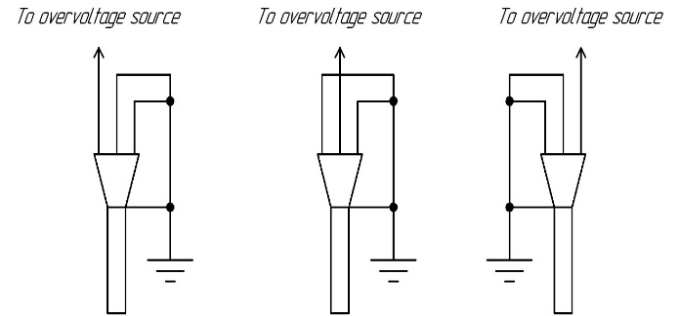 | 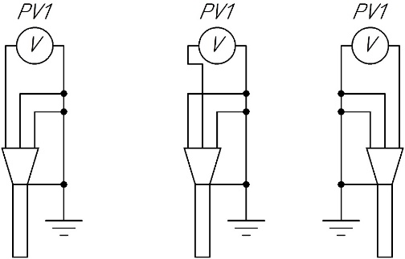
Figure 1. Typical wiring diagram for connecting the test unit. | Figure 2. Wiring diagram of connecting a voltmeter for each cable wire.

When the test voltage is stopped and the test unit is disconnected from the cable line, the tested cable wire will remain under full test voltage relative to the other two wires and the grounded surfaces at the initial moment of time. As a result, the process of discharging the capacitance in the cable begins along the only available circuit – through the active insulation resistance.
Obviously, the better the insulation condition, the higher its resistance and the longer the process of discharging the cable capacity will be. This process can be controlled using a chronometer and a high-precision voltmeter, which allows measuring voltage in range from zero to full test value. In this case, it is required to write down and construct a discharge graph in time-voltage coordinates. The wiring diagram of connecting the voltmeter is shown in Figure 2. The view of the discharge graph for the general case is shown in Figure 3.
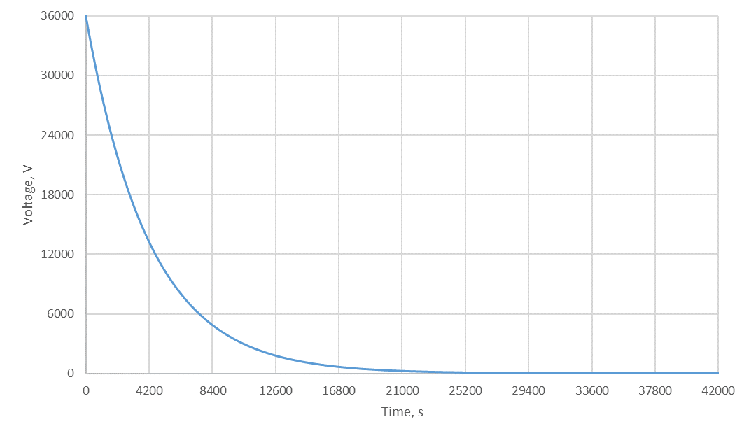 | Figure 3. Cable discharge graph (initial voltage: 36 kV; specific capacity: 0.42 μF/km,  line length: 10 km;  insulation resistance: 1000 MOhm).
At the end of the construction of the discharge graph (Figure 3), it is required to determine the time constant based on the characteristic points of the discharge graph and their correspondence to the typical discharge graph of the capacitor – the voltage reduction to a level of 36.8% of the initial should occur 3 times faster than the reduction to a level of 5.0% of the initial and 5 times faster than 0.7% of the initial. If the actual data significantly differ from the assumed ones, it is concluded that there are insulation defects in cable, the influence of which weakens with a decrease of the voltage value.
If the discharge graph corresponds to a typical one for a capacitor, it is required to determine the insulation resistance based on the obtained value of the time constant and the cable capacity according to the formula (1):
$R_{is}=\frac{τ}{C_{c}}$, (1)
where $τ$ – discharge time constant, seconds;
$C_{c}$ – cable capacity, μF.
In this case, the cable capacity can be calculated by the formula (2):
$C_{c}=c_{0}∙l_{c}$, (2)
where $c_{0}$ – specific capacity of the cable (reference data), μF/km;
$l_{c}$ – cable length (design and/or operational data), km.
It is worth noting that the results obtained by formula (1) $R_{is}$ are presented in megaohms (MOhm) and do not require additional conversion to the insulation resistance measurement units used during testing.
Based on the analysis of the insulation resistance obtained and the correspondence of the discharge graph typical for a capacitor, it can be concluded about state of the insulation a separate cable wire. When carrying out similar actions with other two wires of the cable, a comparative analysis of the insulation condition can be carried out. For a general assessment of the insulation condition of an electric cable, it is recommended to take the smallest of the received resistances as the final insulation resistance. If there are significant differences in the insulation resistance of different wires or in the deviation of one of the discharge graph from the typical one, it is concluded that there are insulation defects. Suitability for further use of cable line in this case is determined only on the basis of the results of tests with increased voltage with a standard level of test voltage.
To obtain more accurate data, the nature of the discharge process flow can be studied for voltmeter wiring diagrams other than those shown in Figure 2. Alternative voltmeter wiring diagrams are shown in Figures 4-7.
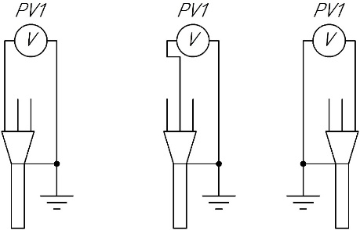 | 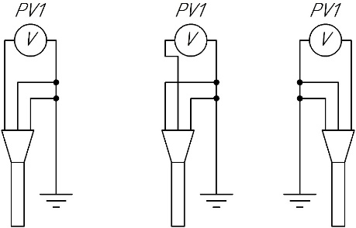
Figure 4. Wiring diagram of connecting a voltmeter for each cable wire. | Figure 5. Wiring diagram of connecting a voltmeter for each cable wire.
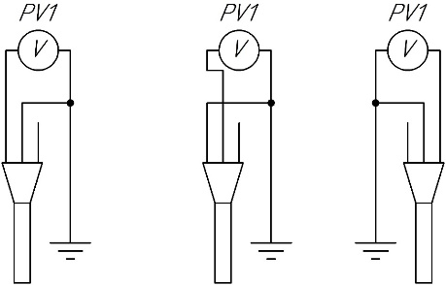 | 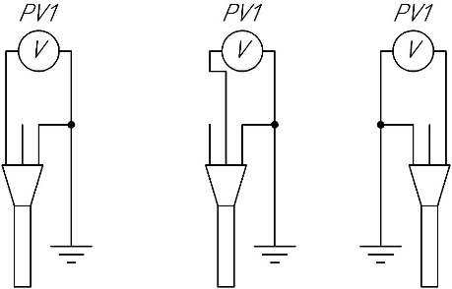
Figure 6. Wiring diagram of connecting a voltmeter for each cable wire. | Figure 7. Wiring diagram of connecting a voltmeter for each cable wire.

It is obvious that in the vast majority of cases in practice, for power cables with a voltage above 1000 V, it is not possible to monitor the discharge process according to the schemes shown in Figures 5-7, due to the absence of a real possibility to ensure reliable insulation of the cable sheath from grounded surfaces along the entire length of the cable due to the fact that the cable sheath is attached to grounded surfaces at the end cutting points and structurally has no insulation from armor and/or protective cover designed for the operating voltage of the cable.
In all cases, the discharge graph must correspond to the typical one for the capacitor, however, the discharge time constant will be different for each of the connection schemes due to changes in cable capacitance (not all cable capacity are involved during discharge).
An assessment of changing the discharge time constant, provided that the insulation resistance remains unchanged, will allow us to estimate the change in the actual capacity of the cable under various switching schemes. The resulting capacitance values must satisfy the following expression (3):
$C_{с}=C_{0}+2∙C_{p}$, (3)
where $C_{c}$ – capacitance between one wire and to the metal sheath and between same wire and other two wires, μF;
$C_{0}$ – capacity between wire and sheath, μF;
$C_{p}$ – capacity between the wires, μF.
According to reference data, the capacity between wire and sheath and the capacity between the wires are related by the expression (4):
$C_{p}=0,27∙C_{0}$, (4)
where $C_{0}$ – capacity between wire and sheath, μF;
$C_{p}$ –capacity between the wires, μF.

4. Results and Discussion
The insulation resistance value can be obtained by formula (1) both using the calculated cable capacity determined by formula (2) and using the actually measured capacity. The processes of measuring capacity are not considered in this research.
To carry out a comprehensive assessment of the cable insulation condition, it is proposed to analyze the discharge time of the cable capacity with different initial voltages, which will allow to confirm or deny a significant change in the shape of the discharge graph or the value of the discharge time constant (and, consequently, the insulation resistance) due to changes in the initial discharge conditions. In the case of significant changes in the nature of the discharge process flow (example in Figure 8), for various initial voltages, it is concluded that there are insulation defects that express themselves with an increase of the voltage applied to the insulation. In this case, the defective part of the insulation can be detected by examining the insulation condition according to the various presented wiring diagrams of connecting a voltmeter. In this case, it becomes possible to determine whether a part of the insulation of the wire from the sheath or part of the insulation between the wires is defective. An example is shown in Figure 9 (an example when the insulation resistance values obtained are different for different switching schemes).
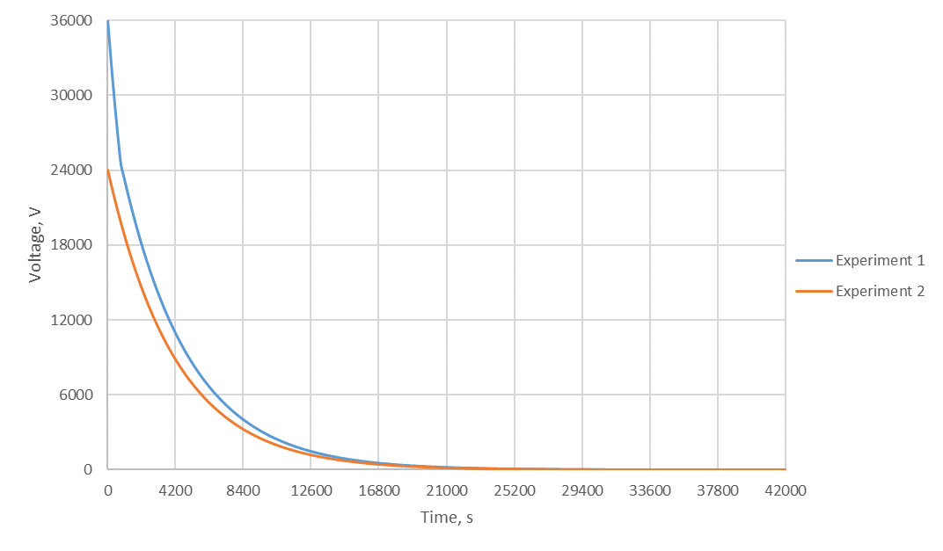 | Figure 8. A comparative picture of the nature of the discharge process flow at different initial voltages.
It is easy to notice that in Figure 8, the discharge of the cable in Experiment 1 at the voltage range from the initial 36 kV to a value close to 24 kV proceeds much faster than at the voltage range from 24 kV to full discharge for each of the experiments. Obtaining such a comparative picture indicates the presence of insulation defects, the influence of which begins to affect when a constant voltage exceeding 24 kV is applied to the insulation of the cable.
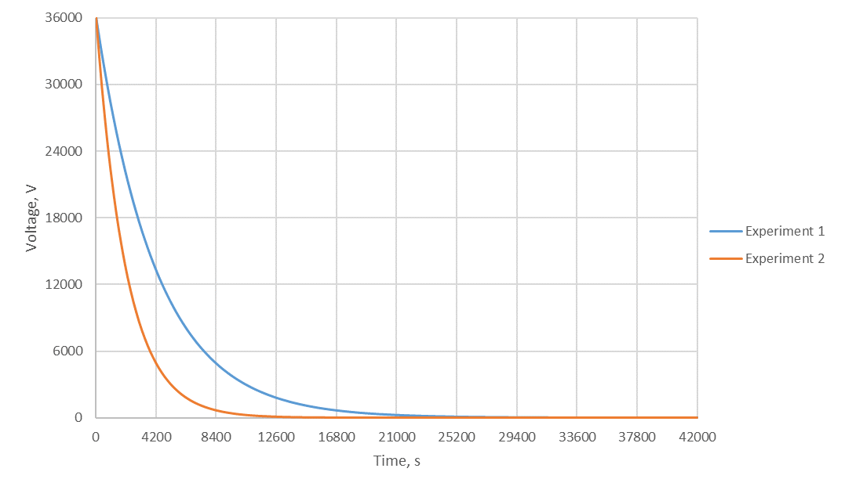 | Figure 9. A comparative picture of the nature of the discharge process flow with different voltmeter connection schemes (various controlled insulation resistances).
It is observed from Figure 9 that the discharge in experiment 2 proceeds much faster, which, given the same initial voltage, indicates a lower insulation resistance compared to that studied in Experiment 1. Similar differences for different insulation resistances (for example, for insulation resistance between wires and between the wire and the sheath) are the expected picture due to the known design features of the electric cable. At the same time, significant deviations of discharge graphs showing significant deviations of insulation resistance values for theoretically predicted identical insulation resistance values (for example, different insulation resistance values between different wires and the sheath or between different wires) clearly indicate the presence of insulation defects and even allow localizing the damaged zone of insulation.

4.1 A model of spreading of the leakage current through the insulation from the test wire to other wires and the sheath.
Graphically, the discharge of charge from the charged core to the grounded parts of the cable with a standard wiring diagram for increased voltage testing (Figure 1) is schematically shown in Figure 10.
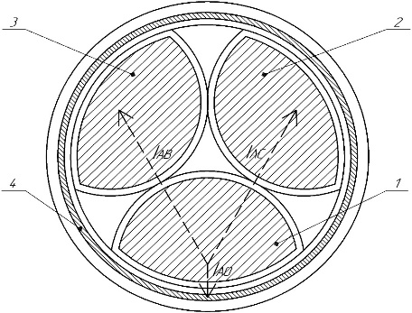 | Figure 10. A schematic representation of the process of charge draining from the charged core to the grounded parts of the cable at the end of the increased voltage testing process for the standard wiring diagram for wire A of the cable ($I_{AB}$, $I_{AC}$, $I_{A0}$ – charge drain currents from the charged wire A to the wires B, C and the sheath, respectively; 1 - wire A of the cable; 2 - wire B of the cable; 3 – wire C of the cable; 4 - cable sheath).
It is easy to notice that the cable assembled according to the test circuit (Figure 1) at the end of the overvoltage set and its holding for a long enough time is a composite capacitor for the flow of electric current due to the termination of the effects of absorption and polarization. At the same time, this capacitor consists of three capacitors physically connected in parallel and having one common positive voltage plates (negative voltage plates are interconnected and grounded). The schematic diagram of the cable for the flow of electric current is shown in Figure 11. The only way to discharge such a capacitor is the transfer of charge between the plates through an insulation layer having a finite resistance.
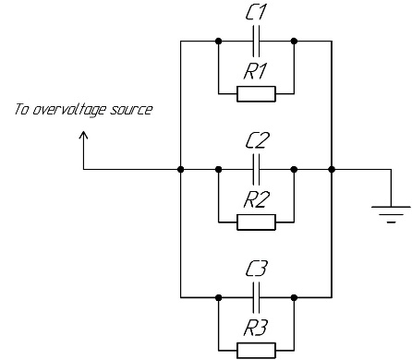 | Figure 11. Circuit diagram of the cable for the flow of electric current through the insulation in the increased voltage test mode with and at its end ($C_{1}$, $C_{2}$ – the capacitance between the test wire and another wire; $C_{3}$ – the capacitance between the test wire and the cable sheath; $R_{1}$, $R_{2}$ – insulation resistance between the tested wire and another wire; $R_{3}$ – insulation resistance between the tested wire and the cable sheath).
4.2 A model for comparing discharge processes.
Two different methods can be used to compare the two discharge processes:
- comparison of two discharges according to a different wiring diagram at the same initial voltage (at the moment of coincidence of the current voltages) – in this case, the discharge time and cable capacity will be different;
- comparison of two discharges according to a different wiring diagram with the same initial voltage for an arbitrary discharge time – in this case, the current voltage and cable capacity will be different.
For the first method, considering that the discharge equation is generally described by the dependence (5), it seems possible to find using equation (6) the capacitances ratio of the tested cable for different discharge schemes.
$U(t)=U_{0}∙e^{-\frac{t}{R∙C}}$, (5)
where $U_{0}$ – initial voltage, V;
$t$ – discharge time, s;
$R$ – insulation resistance, MOhm.
$C$ – capacity of the cable, μF.
$U_{0}∙e^{-\frac{t_{1}}{R∙C_{1}}}=U_{0}∙e^{-\frac{t_{2}}{R∙C_{2}}}$, (6)
where $t_{1}, t_{2}$ – discharge time spent to achieve the same current voltage in various discharge experiments, s;
$R$ – insulation resistance, MOhm.
$C_{1}, C_{2}$ – cable capacity in various discharge experiments, μF.
By the simplest arithmetic operations, an equation of the following form (7) can be obtained:
$\frac{t_{1}}{t_{2}}=\frac{C_{1}}{C_{2}}$. (7)
Provided that the discharge time ratio ($t_{1}$ to $t_{2}$), and the assumed capacitances ratio ($C_{1}$ and $C_{2}$) to the capacitance of the cable $C_{c}$ are known, the correspondence of the theoretical dependencies to the experimental ones can be checked and the assumption of the good insulation condition can be confirmed or disproved, since in the case of damaged sections, the discharge time will be significantly reduced and, therefore, provided that the insulation resistances $R$ in formula (6) remain unchanged, the ratio of capacities $C_{1}$ to $C_{2}$ (obtained by calculation from equation (7)) will not coincide with the theoretically expected one. If the insulation is in good condition, the discharge process will be same according to any of the proposed discharge schemes.
For comparison of two discharge processes using the second described method will initially need to express the dependence (5) through the discharge time $t$ according to the formula (8).
$t=-R∙C∙\ln{(\frac{U(t)}{U_{0}})}$. (8)
In this case, to compare two discharge process using the second described method will need to create an equation of the form (9):
$\frac{C_{1}}{C_{2}}=\log_{\frac{{U(t)}_{1}}{U_{0}}}{\frac{{U(t)}_{2}}{U_{0}}}$, (9)
where ${U(t)}_{1}, {U(t)}_{2}$ – current voltage value on the cable during discharge time $t$ in various discharge experiments, V;
$U_{0}$ – initial voltage, V.
Provided that the voltages ${U(t)}_{1}$, ${U(t)}_{2}$ and $U_{0}$ are known, the process of assessing the insulation state is similar to the one described above for the first comparison method.

4.3 Determination the insulation resistance between the wires and the sheath.
To determine the insulation resistance between the wires and the sheath, it is necessary to connect the cable wires according to the wiring diagram shown in Figure 12 and connect an increased voltage source. At the end of the full test voltage set process and its holding for a time period required by the standards of testing of electrical equipment, it is required to connect measuring devices – voltmeters according to the diagram shown in Figure 13. In this case, the cable will consist of three capacitors, the discharge of each of which will be produced due to the finite insulation resistance between the wires and the sheath. So, when obtaining the discharge graphs of each of the wires to the sheath, conclusions about the state of insulation of the wires from the sheath can be made both in relative (the difference in the nature of the discharges between the different wires) and in absolute (mathematically calculated values of insulation resistance).
During the experiment, it is possible to obtain numerical values of insulation resistances $R_{A0}$, $R_{B0}$, $R_{C0}$ by calculation on the basis of empirically constructed discharge dependences of the various cable capacitances for different resistances.
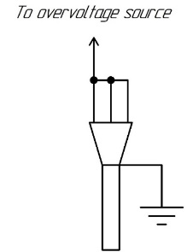 | 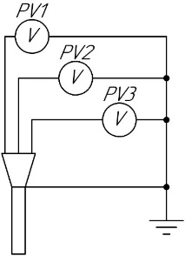
Figure 12. Cable connection diagram for determining the insulation resistance of the cable wires relative to the sheath. | Figure 13. Voltmeters connection diagram for determining the insulation resistance between the cable wires and the sheath.
4.4 Determination of insulation resistance between cable wires.
It is obvious that during the analysis of the discharge graph of the cable according to the traditional diagram of the increased voltage testing, the final value of the insulation resistance obtained as a result of calculations consists of the insulation resistances between the wire and the sheath and between the wire and other two wires connected in parallel. This resistance for the phase A cable wire is described by the expression (10).
$R_{ΣA}=\frac{R_{A0}∙R_{AB}∙R_{AC}}{R_{AB}∙R_{AC}+R_{A0}∙R_{AC}+R_{A0}∙R_{AB}}$, (10)
where $R_{A0}$ – insulation resistance between the phase A cable wire and sheath, MOhm;
$R_{AB}$ – insulation resistance between the phase A wire and phase B wire, MOhm;
$R_{AС}$ – insulation resistance between the phase A wire and phase C wire, MOhm.

It should be noted that the resistances $R_{ΣA}$, $R_{ΣB}$, $R_{ΣС}$ in this article are assumed to be obtained by formula (1).
Expressions similar to expression (10) can be made to describe the insulation resistance of the wires of other phases. In this case, a system of three equations (11) containing three unknowns can be compiled, and each equation will contain two unknowns.
$\left\{\begin{aligned}\frac{1}{R_{AB}}=X-\frac{1}{R_{AC}} \\ \frac{1}{R_{AB}}=Y-\frac{1}{R_{BC}} \\ \frac{1}{R_{AC}}=Z-\frac{1}{R_{BC}}\end{aligned}\right.$, (11)
where $X$ – numerical value of the expression $X=\frac{1}{R_{ΣA}}-\frac{1}{R_{A0}}$ , MOhm;
$Y$ – numerical value of the expression $Y=\frac{1}{R_{ΣB}}-\frac{1}{R_{B0}}$ , MOhm;
$Z$ – numerical value of the expression $Z=\frac{1}{R_{ΣC}}-\frac{1}{R_{C0}}$ , MOhm.
The solution of this system is three expressions (12, 13, 14) that uniquely determine the insulation resistance between the wires based on certain values of the insulation resistance between the wire and sheath and the final insulation resistance between the wire and sheath and between wire and two other wires.
$R_{AB}=\frac{2}{X+Y-Z}$; (12)
$R_{BC}=\frac{2}{Y-X-Z}$; (13)
$R_{AC}=\frac{2}{Z-Y+X}$. (14)
Therefore, within the proposed method, it becomes possible to determine separately the values of insulation resistances between the wires and between the wires and the sheath, which will allow a comprehensive analysis of the insulation condition and assess its residual resource.

4.5 Assessment of the insulation condition.
It is proposed to evaluate the insulation condition based on the following parameters:
- absolute value of insulation resistance;
- coefficient of deviation of calculated values of insulation resistance of various cable wires;
- coefficient of deviation of the ratio of capacities between the wires and between the wires and sheath.
The numerical values of the parameters proposed as criteria for the insulation condition are given in Table 1 for power electrical cables with paper insulation at a voltage from 6 to 35 kV.
The numerical parameters of the absolute values of insulation resistance in Table 1 for a "Satisfactory" insulation condition are given with the assumption that the values of leakage currents of electric cables correspond to the normalized values for power cables in the Rules of Technical Operation of electrical installations of consumers [1], namely, the maximum permissible leakage current for a power cable. The values of the absolute values of the insulation resistance for the "Good" and "Excellent" insulation condition are given with the assumption that the leakage current is reduced by two and four times, respectively. At the same time, based on the standard cable design, the insulation resistances between the core and the shell and between the cores are assumed to differ twice.
The coefficient of deviation of the insulation resistance values shows the uneven wear of the cable insulation and may indicate the presence of local insulation damage, which may be caused by various factors, such as:
- systematic overload of one of the cable wires with increased current loads, leading to overheating of the insulation of the wire – in this case, the insulation both between this wire and other wires, and between this wire and the sheath will be significantly reduced, and the insulation resistance between this wire and the sheath will be reduced more due to the fact that the insulation resistance between the wires includes two independent, electrically connected in series, insulation resistances of the wires;
- deformation of the cable, leading to a partial violation of the insulation layer – in this case, mostly reduced an insulation resistance between one or more wires and the sheath relative to the insulation resistance to the sheath of intact wires.
The coefficient of deviation of the cable capacitance values demonstrates the difference between the empirically obtained values of the cable capacitance ratios between the wires and between the wire and the sheath from the theoretically predicted values. This difference can be caused by various reasons:
- measurement error – due to the fact that the value of the capacitance and the calculation of its ratios are performed by indirect methods and depend on the accuracy of measurements of other quantities (including non-electrical), it is difficult to perform accurate measurements of the cable capacity, however, the value of a relative error of 2% is quite an achievable level of measurement accuracy;
- deterioration of insulation– due to the fact that the process of determining the capacitance ratios is based on analyzing the nature of the discharge process with different connection diagrams, the resulting value of the capacitance ratio depends on the discharge time to the same value of the current voltage, as well as on the expected ratio of insulation resistances with different connection diagrams: in this case, the deviation of the true resistance ratio from the theoretically predicted value will affect the resulting value of the capacitance ratios and indicate the presence of insulation damage in the cable.
Table 1. Numerical values of parameters for assessing the state of insulation of electrical cables.
№ | Rated cable voltage, kV | Rated test voltage, kV | Insulation resistance between the wires, MOhm | Insulation resistance between the wire and the sheath, MOm | Coefficient of deviation of insulation resistance values, % | Coefficient of deviation of capacitance ratios, % | Insulation condition
1 | 6 | 36 | 720 | 360 | from 2,5 to 10,0 | from 5,0 to 10,0 | Satisfactory
2 | 6 | 36 | 1 440 | 720 | from 1,0 to 2,5 | from 2,0 to 5,0 | Good
3 | 6 | 36 | 2 880 | 1 440 | below 1,0 | below 2,0 | Excellent
4 | 10 | 60 | 480 | 240 | from 2,5 to 10,0 | from 5,0 to 10,0 | Satisfactory
5 | 10 | 60 | 960 | 480 | from 1,0 to 2,5 | from 2,0 to 5,0 | Good
6 | 10 | 60 | 1 920 | 960 | below 1,0 | below 2,0 | Excellent
7 | 20 | 100 | 268 | 134 | from 2,5 to 10,0 | from 5,0 to 10,0 | Satisfactory
8 | 20 | 100 | 536 | 268 | from 1,0 to 2,5 | from 2,0 to 5,0 | Good
9 | 20 | 100 | 1 072 | 536 | below 1,0 | below 2,0 | Excellent
10 | 35 | 175 | 280 | 140 | from 2,5 to 10,0 | from 5,0 to 10,0 | Satisfactory
11 | 35 | 175 | 560 | 280 | from 1,0 to 2,5 | from 2,0 to 5,0 | Good
12 | 35 | 175 | 1 120 | 560 | below 1,0 | below 2,0 | Excellent
Moreover, it should be noted that exceeding the value of the actual capacity of the cable relative to the value of its nominal (design) capacity with taking into account the actual length of the cable, should be regarded as a positive factor positively characterizing the state of insulation and favorably affecting the residual resource of the cable insulation.

4.6 Assessment of the residual insulation resource.
It is proposed to evaluate the residual insulation resource on the basis of an assessment of the insulation condition as follows:
- all indicators of the insulation condition indicate an «Excellent» insulation condition – the residual resource is assumed to be comparable to the passport service life, there are no contraindications to testing the cable with a normative value of increased voltage;
- at least one of the indicators indicates a «Good» insulation condition (the others are the same or higher) – the residual resource is assumed to be within 10-15 years; there are no contraindications to testing the cable with a normative value of increased voltage;
- at least one of the indicators indicates a «Satisfactory» insulation condition (the others are the same or higher) – the residual resource is assumed to be within 5 years; it is not recommended to test the cable with a normative value of increased voltage;
- at least one of the indicators indicates an unsatisfactory state of insulation – the insulation resource has been exhausted, or a spot repair of the cable is required (in this case, the insulation should be burned and search for the place of damage should be carried out).

5. Conclusion
The non-destructive nature of the proposed method for monitoring the state of cable insulation consists in the use of a reduced test voltage coupled with the use of the described method for assessing the state of insulation based on the analysis of the discharge time of the cable capacity due to the fact that the test voltage lowered to values determined by local conditions allows testing the cable insulation for withstanding the operating voltage with a given margin factor, after which the insulation condition is assessed according to the proposed method.
Thus, cable insulation does not experience excessive loads during testing and measurements, and the genesis of previously non-existent and the development of existing minor defects is not provoked in the insulation body. However, with sufficient correctness and accuracy for practical purposes, the detection of existing insulation defects is carried out on the basis of indirect measurements. And each type of detected defect can be digitized and comparatively assessed in relation to other cable wires or similar cables in the electrical network of the operated object(s). Within the proposed methodology, are determined both the values of insulation resistances and the values of the capacitances between the wires and other wires and between wires and sheath, as well as their mutual ratios.
The correctness of the methodology for assessing the insulation state based on the analysis of the discharge time of the cable capacity in various diagrams is confirmed by comparing theoretical and experimental data on the discharge of the capacitor on the load (the final active insulation resistance).
Using the proposed methodology for assessing the state of insulation and residual life allows, together with using a test voltage value determined based on local conditions, to extend the useful resource of the cable due to the absence of cases of applying a voltage to the insulation that is many times higher than its normative operational value.
This article presents a method for determining the insulation resistance of a cable based on experimentally obtained data and cable passport values, which makes it possible to evaluate the insulation resistance value within the of high-voltage direct current cable insulation tests.
Also this article presents a model of spreading of the leakage current through the insulation, on the basis of which are given recommendations for comparing the nature of the discharge (two methods) with different cable connection diagrams. The obtained data make it possible to assess the state of insulation in linguistic categories and numerically predict the residual resource of cable insulation.
The theoretical value of this study consists in the development of a methodology for determining the insulation resistance of a cable based on the analysis of the discharge time of the cable capacity, as well as in the development of a model of spreading of the leakage current through the insulation in a three-wire cable with a conductive sheath.
The practical value of this study consists in the possibility of its application during planned testing of cable lines in operating companies in order to conduct non-destructive testing of the insulation condition and to schedule repairs and replacement of cable lines.

References
Rules for the technical operation of electrical installations of consumers: approved by Order of the Ministry of Energy of Russia dated 13.01.2003 N 6 (as amended on 13.09.2018) "On approval of the Rules for the technical operation of electrical installations of consumers" (Registered in the Ministry of Justice of Russia on 22.01.2003 N 4145): put into effect from 01.07.2003 (In Russian).
Vysogorets S. P., Nikonov D. I., Nazarychev A. N., Tadjibaev A. I. Problems of technical diagnostics of 6 (10) kV cable lines with paper-impregnated insulation in modern conditions. Proc. of the Int. Scientific Seminar named Yu.N. Rudenko, Syktyvkar, July 04–09, 2016 «Methodological issues of research on the reliability of large energy systems. – 2016. – P. 180–186 (In Russian).
Biryulin V. I., Kudelina D. V., Larin O. M. Method of monitoring the state of insulation of cable lines. Bulletin of the Voronezh State Agrarian University. – 2020. – Vol. 3. – P. 38–45.
DOI: 10.17238/issn2071-2243.2020.3.38 (In Russian).
Novikova F. Sh. Zh. Da K., Mironova I. S., Chernov K. V., Maksyutov I. N. Assessment of the technical condition of high-voltage cables based on the frequency diagnostic method. Theoretical and applied aspects of modern science. – 2014. – Vol. 6-3. – P. 88–91 (In Russian).
Granizo R., Platero C. A., Guerrero J. M. HVDC Ground Fault Detection Method Based on the Shield Leakage Current Measurement for Long Cable Energization. Proc. of 2020 IEEE Int. Conf. on Environment and Electrical Engineering and 2020 IEEE Industrial and Commercial Power Systems Europe (EEEIC / I&CPS Europe). 2020. P. 1–5.
DOI: 10.1109/EEEIC/ICPSEurope49358.2020.9160778.
Zhou L., Cao J., Wang S., Liu L., Yang Y., Jiang H. Comprehensive State Evaluation of High Voltage Cable Based on Multi-state Variables Characteristics and Variation Law. Gaodianya Jishu/High Voltage Engineering. 2019. Vol. 45(12). P. 3954–3953.
DOI: 10.13336/j.1003-6520.hve.20190424004.
Korzhov A. V., Gorshkov K. E., Korzhova M. E. Neural Networks in Monitoring and Forecast Reliability Cable Network. Proc. of 2018 Global Smart Industry Conf. (GloSIC). 2018. P. 1–6. DOI: 10.1109/GloSIC.2018.8570153.
Zhang H., Mu H., Zou X., Zhang D., Zhang G., Xie C. A Novel Method for Identifying Cable Defect and Improving Location Accuracy Based on Frequency Domain Reflectometry. Proc. of 2021 IEEE 4th International Electrical and Energy Conf. (CIEEC). 2021.
P. 1–5. DOI: 10.1109/CIEEC50170.2021.9510503.
Montanari G. C., Seri P., Bononi S. F., Albertini M. Partial Discharge Behavior and Accelerated Aging Upon Repetitive DC Cable Energization and Voltage Supply Polarity Inversion. IEEE Transactions on Power Delivery. 2021. Vol. 36(2). P. 578–586.
DOI: 10.1109/TPWRD.2020.2984766.
Siodla K., Rakowska A., Noske S. The Proposal of a New Tool for Condition Assessment of Medium Voltage Power Cable Lines. Energies. 2021. Vol. 14(14). P. 4116.
DOI: 10.3390/en14144116.

Information about the authors:
Ivan M. Kazymov, postgraduate at the Department of «Electrification of production and life»;
Phone: +7-(913)-093-52-10;
eLibrary SPIN: 8464-5810; ORCID: 0000-0001-6873-0315; Scopus ID: 57209794071;
E-mail: bahek1995@mail.ru.

Boris S. Kompaneets, Ph. D. (Engineering), Docent, Head of the Department of «Electrification of production and life»;
eLibrary SPIN: 7371-4290; ORCID: 0000-0001-5980-1230; Scopus ID: 57209796863;
E-mail: kompbs@mail.ru.

