Calculation features of compressed-bent build-up timber columns with nonlinear-deformable shear bracings

E V Popov1, A V Karelsky1, V V Sopilov1, B V Labudin1, V V Cherednichenko1

1Northern (Arctic) Federal University named after M.V. Lomonosov, Department of Engineering Structures, Architecture and Graphics, 163002, Arkhangelsk, Russian Federation

**Abstract.** Object of research is build-up compressed–bent and eccentrically compressed columns on yielding nonlinear – deformable shear bracings. Purpose of the research is development of a numerical method for calculation of columns, allowing to take in account the influence of deflection of elastic axis of bar on the increment of the bending moment from the action of longitudinal compressive force and the nonlinear dependence between the forces and deformations in the shear bracings. Problem-solving method consists in dividing the column into separate sections, a system of equations is compiled from the condition of equality of the increment of concentrated shears. The loading process is divided into a set number of stages, at each forces in the shear bracings, the stresses in the branches, and the buckling function of the elastic axis of the element are determined. The obtained values of forces in the shear bracings and buckling are used to specify stiffness of the bracings and component of the bending moment arising due to eccentric application of the longitudinal compressive force when longitudinal axis of the element is deflecting. To obtain the resulting values, the obtained forces, deflections and stresses in the branches at each calculation stage are summed up.

1. Introduction

Structural timber and timber–composite structures are used as raw material for production of various types of building structures due to the fact, that such structures have high architectural merit. They are reliable, strong, durable, and at the same time such structures are lightweight. Structural timber is a very economical material, which resistant to aggressive environments. In many countries of the world there is a huge renewable raw material base to produce such structures. The use of timber in the construction of public, industrial, agricultural, multistory residential and store frame buildings is becoming more and more popular. Generally, the major load–bearing elements of such buildings are timber or timber–composite columns.

The basis of modern timber frame buildings is made up of two–hinged and three–hinged frameworks, the basic vertical load–bearing elements of which are timber build–up and lattice columns (Figure 1). Several new design efforts [1] have made it possible to design such columns with a rigid joint in the support section.



**Figure 1.** Build–up timber columns: a – with bolt connections; b – the same with gaskets;

c – lattice column with combined bolt and claw washer connections; d – the same with metal–toothed plate (MTP) connections; e – I-section column with oriented strand board (OSB) wall

Despite extensive research in the field of calculations, design and testing of build–up timber and timber–composite columns, they are applied only to structures with rigid shear bracings between the composition layers. There are no studies of the behavior of such structures in the presence of compliance of discrete bracings.

When calculating such structures, it is important to consider the curvature of the elastic axis of the column under the action of transverse forces. For build-up columns with yielding bracings this issue deserves special attention because the bending stiffness of composite elements is much lower than for columns with solid cross-section. This fact significantly affects the increase of the bending moment component under the action of a longitudinal compressive force. The method for calculating build-up columns on yielding bracings, given in [2], assumes the use of a linear stiffness coefficient ku. This coefficient does not allow taking into account the real nature of the deformation of connections and thereby the redistribution of forces due to a decrease in the stiffness of more loaded connections, and a decrease in the bending stiffness of the entire structure at loading it.

The object of our research was compressed–bent build–up timber columns. The subject of the research was non–linear dependence «load-shear» of bracings and the deformability of such structures. The purpose of the article was to design a step method for calculation, which considers the increase of bending moment component because of eccentric compressive force, and non–linear deformability of shear bracings. The main objective of our research was to calculate a two–layer build–up timber column according to the developed mathematical model, and to compare the exact and approximate calculations of such a structure with the assumption of a different number of iterations and a different approach for determining the elastic modulus of bracings.

1. Materials and methods

There is a nonlinear dependence between the force value and the deformation of the connection for most types of shear bracings: dowels [3], bolts [4], MTP [5], claw connectors [6], screws [7], clamps [8], etc. Thereby, it is necessary to consider the change in stiffness depending on the forces for build-up columns with nonlinearly deformable yielding connections. The stiffness coefficient of each bracing should be considered as a function [9]:

 (1)

where *c* is shear stiffness coefficient of the single bracing; *T*c is the force per bracing.

The scheme of build–up column is shown in Figure 2. Forces *T*c are arising in the shear bonds under the action of a bending moment, the nature of the distribution of which depends on the form of the end restraint and the load case. When the load is transferred to the column centrally in the initial undeformed state, the longitudinal force is distributed between the branches in proportion to their longitudinal stiffness *EF*, and the forces in the shear bracings is equal to *T*c=0. Under the action of a transverse load *q*(*z*) (where *z* is the coordinate, measured along the height of the bar), the column axis is beginning to deflect from the vertical, a bending moment *M*0,q from the transverse load *q*(*z*) application and a bending moment *M*0,*N* appears because of eccentric longitudinal force ∑N application, *M*0,N =*е*(*z*)∙∑*N* (where *e*(*z*) is the eccentricity function). Here and further in the text, the index “0” means that the force factor is determined without taking account of the shear forces in the discrete bonds.

**Figure 2.** Compressed–bent composite element with yielding discrete shear bracings: *a* is numbering of bracings and sections; *b* is a scheme of the deformation of the column under the combined action of a compressive force and transverse load; *c* is an epure of bending moments *M*0,q an *M*0,N

Let us consider *i*–th section. The increment of the concentrated shear along the length of the selected section is equal to the difference between the shears of the *i*–th and *i–*1–th bracings:

 (2)

where *c*i is the stiffness coefficient of the *i*–th bracing; *z*i is coordinate, which measured along the length of the *i*–th section; γ, ∆i are parameters, which determined by the formulas:

 (3)

где *F*1, *F*2, *E*1; *E*2 are cross sections and elastic moduli of branches material of build–up column; *N*1; *N*2 are longitudinal forces in branches; *w* is the distance between gravity centers of cross section of branches; ∑*EI* is the sum of the stiffness of the branches: Σ*EI=E1I1+E2I2*; *M*0,i(*z*i) is the function of bending moment distribution within the *i*–th section: *M*0,i= *M*0,I,q+ *M*0,i,N.

Equations (2) allows to get for each section a system of equations for determining the shear forces in bracings. The end point should be taken as the section in which the concentrated shear Г=0. For example, for a rigidly supported console, such section is the support section; for a column pin–supported at the ends without obstacles to shear is the point at which the epure *Q*0 changes sign. In this case, for asymmetric loading schemes, systems of equations should be compiled separately for each column parts below and above the section without concentrated shear.

 (4)

The system of equations (4) can be represented in matrix form:

 (5)

where *X* is the matrix of unknown shear forces *T*c,i; *A* is the matrix of coefficients of unknown shear forces *T*с,i (formula (6)); *B* is the matrix of free terms (integrals in the right side of equations (4)).

|  |  |
| --- | --- |
|  | (6) |

The solution of the system of equations gives the values ​​of the shear forces in bracing, and the considered scheme becomes statically definable. The stresses in the branches are determined according to the common structural mechanics rules.

The complexity of this solution in an analytical form for compressed–bent columns with nonlinear-deformable shear bracings is that the bending moment in the sections of the column can be calculated only when the horizontal displacements are known, at the same time, the latter cannot be determined without values of the bending moments and shear bracings forces, the stiffness of which, in turn, depends on the shear forces acting in them. A numerical algorithm for solving such a problem, which consists in the following, is proposed in this paper:

– the transverse load *q*(*z*) is applied in steps of δ*q*, and the longitudinal compressive force at the initial stage of the calculation has a full value due to the fact, that longitudinal force in the columns, as a rule, is created due to constant, useful and snow loads, which are long–acting in nature, in contrast to the transverse load *q*, which usually arises due to the wind pressure;

– at each stage of the calculation, the forces in the shear bracings, the stresses in the branches and the displacements of the bar are determined. The displacements values is used to refine the component of the bending moment *M*0,N for the next stage. The stiffness coefficients of the bracings *c*i are refined for the next step, depending on the magnitude of the acting shear forces, which are unevenly distributed between the bracings;

– stresses in the branches and forces in shear bracings are summed up at each stage of the calculation, based on the resulting values of which conclusions about ensuring the strength and rigidity of the structure are formulated.

The common algorithm for axis displacements of a build–up structure determining, considering the nonlinear compliance of shear bracings, is described in [10].

The equation of the bending line of the section between the top of the column and bracing 1 (section 0) is as follows:

 (7)

For other sections (*i*=1, 2…*n*):

 (8)

where *e*j–1(*z*) is the eccentricity function of the application of the longitudinal force, calculated at the *j*–1 stage of the calculation.

The solutions to equations (7) and (8) will be presented in the form:

 (9)

where Фi(*z*i) are functions that are the general solution of indefinite integrals of expressions (7) and (8); *C*i, *D*i are arbitrary constants.

To determine arbitrary constants, a system of equations is drawn up that connects deflections and angles of rotation at the boundaries of the sections (continuity conditions). For a column rigidly clamped in the support section, considering the equality of the deflection and the angle of rotation in it to zero, the system of equations can be written in the form:

|  |  |
| --- | --- |
|  | (10) |

The system of equations can be represented in matrix form (5):

|  |  |
| --- | --- |
|  | (11) |

The required horizontal displacement function is found by approximating the obtained values at the characteristic points.

As an example, a build-up timber column of the cross frame of a one–storey building with a timber frame (Figure 3, a) made of pine wood of C22 strength class with a modulus of elasticity *E*=6.7 GPa is considered. The branches of the build-up column are connected by steel bolted joints and toothed connectors. The deformation of the joints occurs according to a nonlinear behavior, the stiffness parameter of the joints is determined by the dependence *c*=*c*(*T*c) (Fig. 3, b). The deformation of structural timber is assumed to be linearly elastic. The parameters, which are taken as initial data: column height *H*=3.2 m, cross–sectional dimensions of branches (*b*×*h*) 200×150 mm, spacing of shear bracings 0.5 m. The column is loaded with a longitudinal force ∑*N*=200 kN, transmitted to the column centrally through a special cap. A uniformly distributed transverse wind load with intensity *q*=5 kN/m acts on the column. It is required to determine the shear forces in bracings, displacements of axis and maximum edge stresses in the branches of a build-up column.

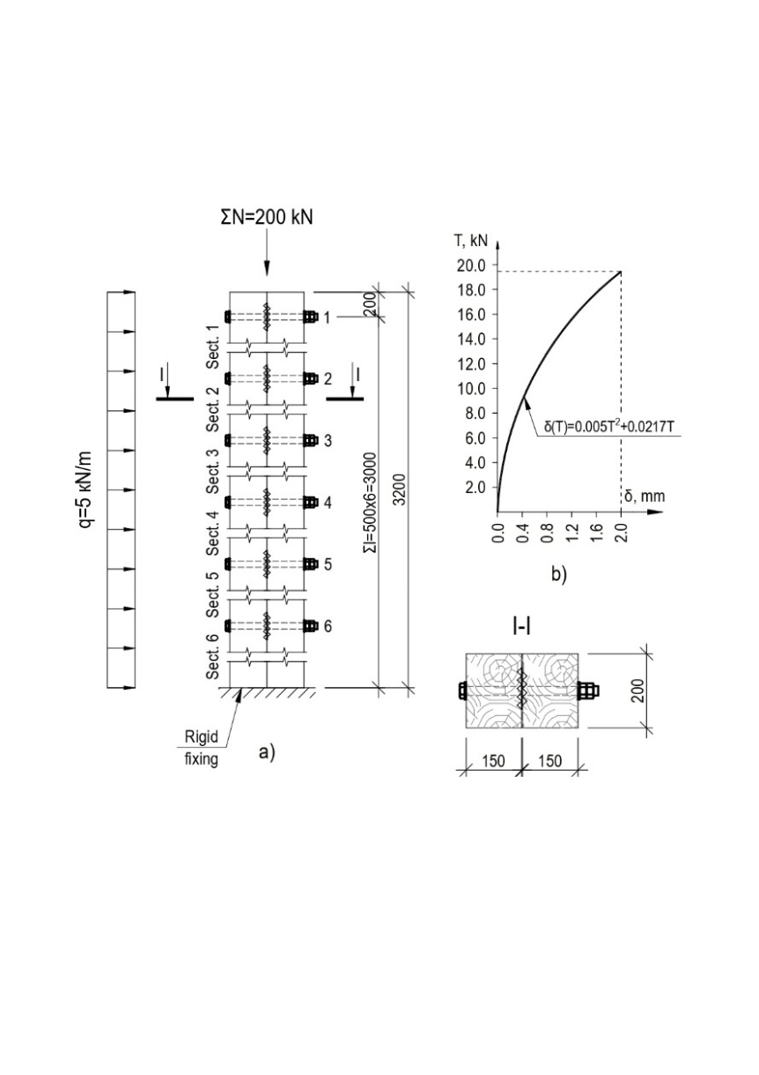

**Figure 3.** The calculation model of a build–up column with yielding bracings: *a* – column design; *b* – diagram «load–deformation» (T – δ) dependence for a single bolted bracing under the action of longitudinal shear

The column is separated into 7 sections of length *l*j. Shown below the functional dependences of bending moments distribution along the length of the sections М0,i(zi) at the j–th stage of the calculation:

– Section 0:

 (12)

– Section 1:

 (13)

–Section *i* (*i*=2…6):

 (14)

To determine the forces in the shear bracings at each stage of the calculation, a system of equations (4) is drawn up, then - a system of equations for determining arbitrary constants *C*0, *D*0, … *C*6, *D*6 according to the expression (9). Horizontal displacements are calculated at distinguished points along the column height: at the top level and at each bracing. Horizontal displacements are determined by formula (9) at points corresponding to the beginning and end of the sections. The approximating buckling functions are taken in the form of 3-degree polynomials, allowing to obtain a high degree of accuracy of the approximation (R≥0.995):

 (15)

where *a*j, *b*j, *c*j are polynomial coefficients calculated by the *j*-th stage of the calculation.

The eccentricity function *e*j, at the *j*-th stage of calculation, corresponding to the column deformation scheme shown in Fig. 2b will be of the form:

 (16)

The stiffness coefficients of the bracings at the *j*–th stage of calculation are determined by the forces, which obtained at the *j*–1–th stage of the calculation and are refined by the formula:

 (17)

where is the total value of shear forces in the *i*–th bracing, obtained at the previous *j*–th stages of the calculation;  is deformation of the *i*–th bracing at a assumed load, determined by the approximating curve of the graph of the deformation of the connection in Fig. 3.

The edge normal stresses σx in the relevant cross–section are determined by the formula:

 (18)

where  are edge normal stresses at the *j*–th stage of the calculation, which obtained without considering the action of the longitudinal compressive force ∑*N* (considered only when calculating the bending moment), determined for 1st and 2nd branches, respectively, by the formulas:

 (19)

where is the total value of the forces in the shear bracings above the considered cross-section at the *j*–th stage of the calculation;  is bending moment, obtained in the considered cross-section at the *j*–th stage of the calculation without taking into account shear forces in the bracings; *h*1, *h*2, *F*1, *F*2, *I*1, *I*2 are cross–section height, сross–sectional area and moments of inertia of the 1st and 2nd branch, respectively.

The calculation is performed with the number of stages: *m*=1, 2, 5, 10, 15 and 20. For the first stage of loading, the stiffness coefficient of the connection is taken equal to the tangent of the angle of arrival, drawn through the initial point of the graph to the axis of abscissae (δ). At this stage, horizontal displacements are determined only by the action of a lateral load. At each stage of the calculation, the values ​​of the forces in bracings *T*i are determined from the solution of system of equations (5) and the horizontal displacements of the top of the column. According to the data obtained, the parameters of the stiffness of the connections *c*i and the coefficient αj, considering the influence of the buckling of the element on the bending moment, are refined for the next stage of the calculation. The values ​​of the shear forces in the bracings to clarify the stiffness coefficients ci at the next stage of the calculation are taken equal to the sum of the forces at the previous stages of the calculation.

To compare the results, a calculation is made at a constant value of the stiffness coefficient of connection *k*u, which, according to [13], is determined by the formula (22) for bolted joints with toothed connectors:

 (20)

where *k*ser is norm stiffness coefficient of connection, defined as a secant modulus at a load equal to 40% of the admissible limit value.

1. Results and discussion

The graphs in Figure 4 shows the values of the shear forces in the bracings for a different number of calculation stages *m*. The variant of calculation with *m*=20 is hereinafter accepted as a «reference» one.

In the linear calculation (*m*=1, the forces in the shear bracings are determined without considering the eccentric application of the longitudinal force, the stiffness coefficient of the bracings is determined by formula (20)) the error is 30...42%. A further increase in the number of iterations gives the following errors: 2...26% at *m*=2; 1...7% at *m*=5; 1...3% at *m*=10; 0.5...1% at *m*=15. Calculation with a linear value of the stiffness coefficient, calculated by the formula (20), with the number of iterations *m*=10 gives an error of 3...22%. Thuswise, to obtain reliable values ​​of the shear forces in the bracings, which are necessary for checking the strength of the connections, *m*=5...10 iterations should be enough.

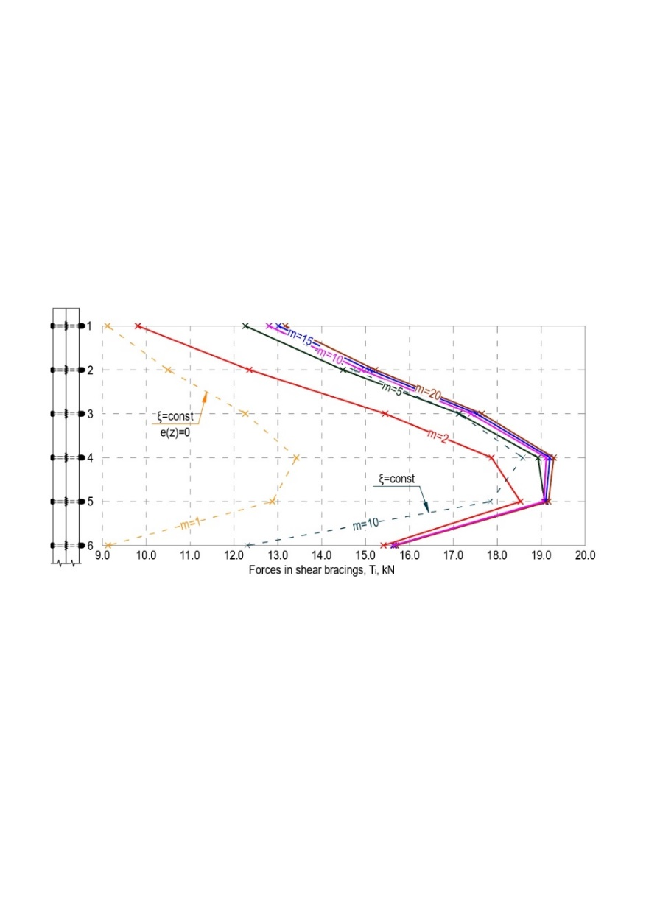

**Figure 4.** Forces in shear bracings *T*i for different numbers of iterations *m*

The graphs in Figure 5 shows the values of horizontal displacements. In a linear calculation (m=1, the forces in the shear bracings are determined without considering the eccentric application of the longitudinal force, the stiffness coefficient of the bracings is determined by formula (20)), the error is 18%. A further increase in the number of iterations gives the following errors: 26% for *m*=2; 10% at *m*=5; 4% at *m*=10; 1.5% at *m*=15. Calculation with a linear value of the stiffness coefficient calculated by formula (02), with the number of iterations *m*=10, gives an error of 14%.

It should be noted that the difference in indicators in favor of a linear calculation at *m*=1 compared to nonlinear at the number of iterations *m*=2 is only a special case, since it is due to the underestimated value of the linear stiffness coefficient of the shear bracings, which introduced into the calculation.

The accuracy of the obtained values ​​of horizontal displacements is important not only for the deformability of a structure estimation, but also for an adequate material strength assessment and shear bracings. Deflection of the longitudinal axis of the element leads to a significant increase in the component of the bending moment *M*0,N. This is especially important to consider when calculating build–up columns with yielding bracings, which deformability is much higher than solid elements with the same cross-section one. To obtain reliable results of horizontal displacements, it is recommended to use at least *m*=10 iterations.

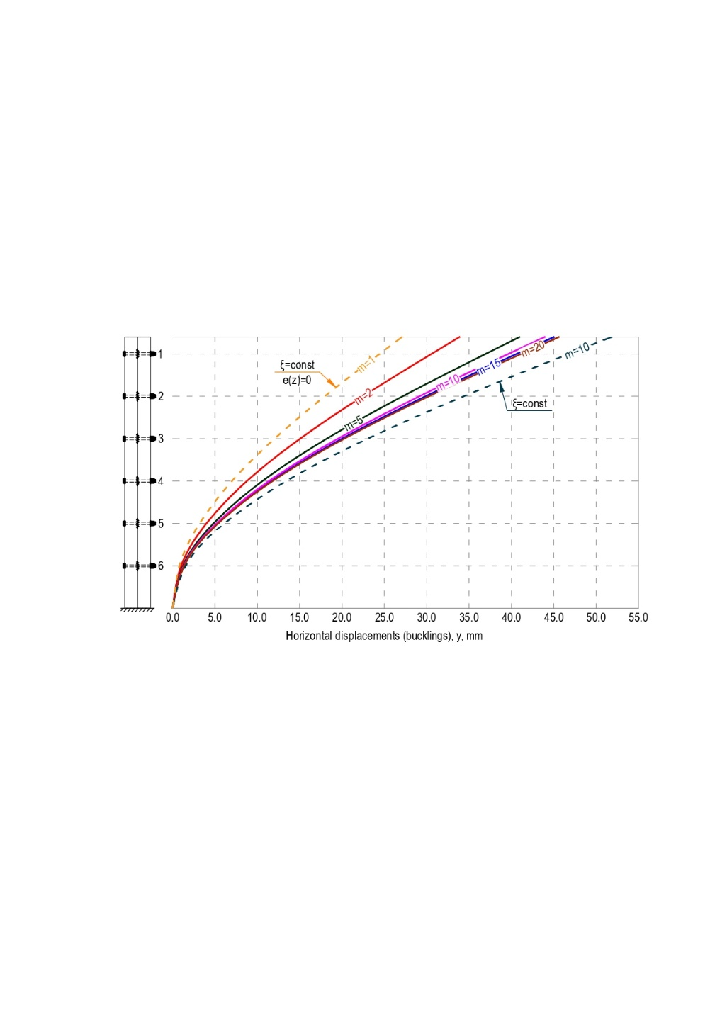

**Figure 5.** The deflection graphs of the elastic axis of the column *y*(*z*) during transversive-longitudinal bending

Figure 6 shows the of normal stresses epures in the branches in the cross-section of the rigid fixing of the column. In a linear calculation (*m*=1, the forces in the shear bracings are determined without considering the eccentric application of the longitudinal force, the stiffness coefficient of the bracings is determined by formula (20)), the error is 11...29%. A further increase in the number of iterations gives the following errors: 8 ... 28% at *m*=2; 3...9.5% at *m*=5; 1...4% at *m*=10; 0.5...1.5% at *m*=15. Calculation with a linear value of the stiffness coefficient, calculated by the formula (20), with the number of iterations *m*=10 gives an error of 6...26%. The largest dispersion of values is typical for the inner edge of the second branch. The leap of stresses is due to the compliance of shear bracings. With a high stiffness of the shear bracings and a small spacing (*c*i→∞), the difference in the values ​​of normal stresses on the internal edges of the branches tends to zero. In this case, the strength condition of the structure can be both the values ​​of tensile stresses from the external side of first branch and maximum compressive stresses from the external side of second branch. This is due to the lower tensile strength of timber than compressive strength. To obtain adequate values ​​of normal stresses, it is recommended to use the iteration value m=10.



**Figure 6.** Normal stress distribution diagrams σx in the branches of the built-up column

1. Conclusions

1 A numerical methods for compressed–bent and eccentrically–compressed build–up columns with yielding shear bracings calculating is presented. It allows to take the influence of the deflection of the elastic axis of the bar on the increment of the bending moment from the longitudinal compressive force operation and the nonlinear dependence between forces and deformations in the shear bracings. The calculation is performed using a n-step method (the loading process is separated into a adjusted number of stages *m*). Formulas for calculating the shear forces in the bracings, horizontal displacements of the elastic axis and edge normal stresses in branches are obtained.

2 The calculation of a cantilever two–branch compressed–bent timber column with a different number of iterations, as well as in a linear statement. The use of the linear coefficient of stiffness of the connections *k*u gives an error in the forces of the shear bracings determining up to 42%, horizontal displacements – up to 26%, stresses in the branches – 11...29%.

3 For a proper evaluation of the stress-strain state of such structures, the number of iterations should be taken *m*=10. A further increase in the number of iterations gives insignificant divergence in the required values.

1. References

[1] Rimshin V, Labudin B, Morozov V, Orlov A, Kazarian A and Kazaryan V 2019 Calculation of Shear Stability of Conjugation of the Main Pillars with the Foundation in Wooden Frame Buildings Advances in Intelligent Systems and Computing. 983 9 doi:10.1007/978-3-030-19868-8_85

[2] CEN EN 1995−1−1:2004/A2−2014 Eurocode 5: Design of timber structures − Part 1−1: General − Common rules and rules for buildings. URL: https://docs.cntd.ru/document/552380618 (date of application 05.09.2021)

[3] Šmak M and Straka B 2014 Development of new types of timber structures based on theoretical analysis and their real behaviour Wood Research. 59(3) 11

[4] Lokaj A and Klajmonová K 2014 Round timber bolted joints exposed to static and dynamic loading Wood Research. 59(3) 9

[5] Karelskiy A V, Zhuravleva T P and Labudin B V 2015 Load-to-failure bending test of wood composite beams connected by gang nail Magazine of Civil Engineering. 54(02) 8 doi:10.5862/MCE.54.9

[6] Chernykh A, Danilov E and Koval P 2020 Stiffness Analysis of Connections of LVL Structures with Claw Washers Lesnoy Zhurnal (Forestry Journal). 4 10 doi:10.37482/0536-1036-2020-4-157-167

[7] Baszeń M 2017 Semi-rigid Behavior of Joints in Wood Light-frame Structures Procedia Engineering. 172 7 doi:10.1016/j.proeng.2017.02.022

[8] Hassanieh A and Valipour H 2020 Experimental and numerical study of OSB sheathed-LVL stud wall with stapled connections Construction and Building Materials. 233 doi:10.1016/j.conbuildmat.2019.117373

[19] Labudin B, Popov E, Vladimirova O, Sopilov V and Bobyleva A 2021 Wood-Composite Structures with Non–Linear Behavior of Semi-Rigid Shear Ties Construction of Unique Buildings and Structures. 97 doi: 10.4123/CUBS.97.2

[10] Popov E V, Sopilov V V, Bardin I and Lyapin D M 2021 Calculation of Vertical Deformations of Composite Bending Wooden Structures with Non–linear Behavior of Shear Bonds Environmental and Construction Engineering: Reality and the Future. 160 7 [doi:10.1007/978-3-030-75182-1_15](https://doi.org/10.1007/978-3-030-75182-1_15)